

Smart Lawyer Assistant

A Senior Graduation Project Report – submitted to complete the requirements
for obtaining a bachelor's degree in artificial intelligence engineering –
Artificial Intelligence & Data Science Engineering

Prepared by

Hasan Salameh

Supervised by

Dr. Eng. Assef Jafar Eng. Aya Alaswad

2026

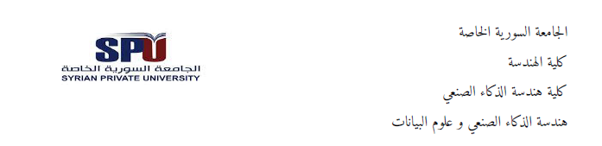

Smart Lawyer Assistant
مشروع تخرج مُقدَّم استكمالاً لمتطلبات الحصول على درجة البكالوريوس
في هندسة الذكاء الاصطناعي - هندسة الذكاء الاصطناعي وعلوم البيانات

إعداد

حسن سلامه

بإشراف

د. م. آصف جعفر م. آية الأسود

2026
SUPERVISION CERTIFICATION

Supervision Certification
I certify that the preparation of this project entitled "Smart Lawyer Assistant", prepared by Hasan Salameh, was made under my supervision at the Faculty of Artificial Intelligence Engineering, Syrian Private University, in partial fulfillment of the requirements for the degree of Bachelor of Artificial Intelligence & Data Science Engineering.

Name: Dr. Eng. Assef Jafar Signature: ...................

Name: Eng. Aya Alaswad Signature: ...................

D E D I C A T I O N

رَبِّ ارْحَمْهُمَا كَمَا رَبَّيَانِي صَغِيرًا
(الإسراء ١٧:٢٤)
To my family,
whose patience, sacrifices, and unconditional support
have been the foundation upon which this work was built,
and whose belief in me has been my greatest source of strength.

ACKNOWLEDGMENT

‬
الـحـمـدُ للهِ الذي لولا توفيقهُ لـمـا خـطَّ الـقـلـمُ حـرفـاً، ولا بـلـغَ الـبـحثُ قـصـداً‬
The author wishes to express sincere and heartfelt gratitude to all those who contributed, in any capacity, to the successful completion of this senior graduation project.
First and foremost, deepest appreciation is owed to Dr. Eng. Assef Jafar, project supervisor, for his expert academic guidance and rigorous technical mentorship throughout every stage of this work. Dr. Jafar’s depth of knowledge, his demanding yet constructive approach to engineering research, and his thoughtful direction were instrumental in shaping the system’s architecture and in ensuring the work met the high standards expected at the Faculty of Artificial Intelligence Engineering. His critical engagement with complex technical challenges and his unwavering commitment to academic quality substantially elevated both the depth and the rigour of this project.
The author also extends sincere gratitude to Eng. Aya Alaswad, practical project supervisor, for her dedicated follow-up, continuous support, and constructive recommendations throughout the project lifecycle. Eng. Alaswad’s professionalism, attention to detail, and commitment to quality consistently guided the project forward at every stage. Her patient mentorship, practical insight, and outstanding coordination skills made a significant and lasting contribution to both the progress and the outcomes of this work, and her guidance was a constant source of encouragement throughout the entire journey.
Special appreciation is owed to the three licensed Syrian family law attorneys who generously volunteered their time and domain expertise for the independent evaluation of this system. Their expert review of the generated legal documents, grounded in years of active courtroom practice, was indispensable for validating the real-world utility and professional accuracy of the system. Their willingness to engage with this academic endeavour reflects a commendable commitment to the advancement of legal technology in Syria.
The author is also grateful to Syrian Private University, and specifically to the Faculty of Artificial Intelligence Engineering, for providing the institutional resources, academic environment, and technical infrastructure that made this research possible. The Faculty’s commitment to applied research and its encouragement of innovation have been a constant source of motivation throughout this academic journey.
Finally, the author extends heartfelt thanks to every person who contributed to this project in any way — colleagues who offered feedback, peers who provided encouragement, and all those who shared their time, knowledge, or support at any stage of this work. This project is as much a product of their collective generosity as it is of the author’s own effort, and their contribution is deeply valued and gratefully acknowledged.
ABSTRACT
The Syrian legal system presents a complex and demanding information environment for practicing lawyers. Navigating more than 800 statutory articles across the Personal Status Law (1953) and the Civil Procedure Code (2016), alongside a specialized corpus of 28 formal document templates, requires substantial time and expertise. No Arabic-language AI system has previously been built to address this workflow.
This project introduces the Smart Lawyer Assistant — to the best of the author’s knowledge, the first AI-powered legal support system specifically designed for Syrian lawyers, built to handle three core professional tasks: answering legal questions with citations to specific statutes, generating formally correct court documents ready for immediate use, and identifying all required attachments for a given case type. The system supports Modern Standard Arabic, Syrian colloquial dialect, and English inputs, making it accessible to legal professionals across different communication styles.
The system is built on a True Hybrid Retrieval-Augmented Generation (RAG) architecture that independently combines dense semantic search using Cohere multilingual embeddings with BM25 sparse retrieval operating over a complete 831-document corpus. A Reciprocal Rank Fusion (RRF) algorithm merges four independent ranked lists (Dense×laws, Dense×osoul, BM25×laws, BM25×osoul), followed by graph-based neighbor expansion over a deterministic legal knowledge graph containing 831 nodes and 2,884 verified edges. The graph is constructed entirely from the structural properties of the legal statutes — article cross-references, thematic groupings, and numeric adjacency — achieving zero spurious edges without any LLM involvement in graph construction.
A four-class intent classifier employs a two-layer waterfall architecture: a rule-based layer resolves 21.4% of queries at zero API cost, while a Groq-hosted LLaMA-3.1-8b model handles the remaining queries. The classifier achieves 92.9% accuracy across 28 diverse test cases. The LLM response layer uses independent handlers per intent class to eliminate context contamination and hallucination, with model selection optimized per task: LLaMA-3.3-70b for legal question answering and LLaMA-3.1-8b for document generation and conversational tasks.
Evaluation using the LLM-as-a-Judge methodology (following Zheng et al., 2023) yields an overall score of 8.3/10, with a hallucination resistance score of 9.0/10 — the most critical metric for a legal AI system. Three licensed Syrian lawyers independently validated the system using active cases from their practice and confirmed that generated documents were formally correct and required minimal to no modification before court use. System evaluation uses two complementary methodologies: LLM-as-a-Judge for objective quantitative quality assessment, and professional expert evaluation for real-world utility validation. The system is deployed via FastAPI with Docker containerization, SQLite-based persistent session management, and a real-time streaming Arabic interface.
Keywords: Retrieval-Augmented Generation, Arabic Legal NLP, Hybrid Search, BM25, Graph RAG, Syrian Law, LLM, Intent Classification, RRF, Hallucination Resistance

الملخص

يُمثّل النظام القانوني السوري بيئةً معلوماتيةً بالغة التعقيد بالنسبة للمحامين الممارسين. فالتنقل بين أكثر من 800 مادة قانونية موزعةً على قانون الأحوال الشخصية (1953) وقانون أصول المحاكمات المدنية (2016)، إلى جانب مجموعة متخصصة من 28 قالب صياغة قانونية، يستلزم وقتاً طويلاً وخبرةً عميقة. يقضي المحامون السوريون جهداً كبيراً في البحث عن النصوص القانونية الصحيحة، وصياغة عرائض المحاكم من الصفر، وتحديد المستندات المطلوبة لكل نوع من أنواع الدعاوى، في غياب أي نظام ذكاء اصطناعي عربي مخصص لهذا الغرض.
يقدّم هذا المشروع المساعد القانوني الذكي — أول نظام دعم قانوني بالذكاء الاصطناعي مصمم خصيصاً للمحامين السوريين — ليتولى ثلاث مهام مهنية محورية: الإجابة على الأسئلة القانونية مع الإشارة إلى المواد المحددة، وتوليد مستندات قانونية رسمية جاهزة للاستخدام الفوري، وتحديد المرفقات المطلوبة لكل نوع من الدعاوى. يدعم النظام اللغة العربية الفصحى واللهجة السورية العامية واللغة الإنجليزية.
يُبنى النظام على معمارية استرجاع وتوليد هجين حقيقي (True Hybrid RAG) تجمع بين البحث الدلالي الكثيف عبر تضمينات Cohere متعددة اللغات وخوارزمية BM25 للبحث المتفرق على corpus كامل من 831 وثيقة. تُدمج خوارزمية Reciprocal Rank Fusion أربع قوائم مستقلة، يعقبها توسيع قائم على شبكة معرفية قانونية حتمية تحتوي على 831 عقدة و2884 رابطاً حقيقياً، مبنيةً كلياً من خصائص النصوص القانونية دون أي تدخل نموذجي.
يُحقق مصنف النوايا ذو البنيتين المتتاليتين دقةً بلغت 92.9% على 28 حالة اختبار متنوعة، فيما تستخدم طبقة الاستجابة باللغة الكبيرة معالجات مستقلة لكل فئة من النوايا للقضاء على تلوث السياق والهلوسة. أسفر تقييم LLM-as-a-Judge عن متوسط عام 8.3/10 مع درجة 9.0/10 لمقاومة الهلوسة. أكّد ثلاثة محامين مرخصون استخدموا النظام على قضايا حقيقية من ممارستهم اليومية أن المستندات المُولَّدة كانت دقيقةً رسمياً وجاهزةً للطباعة دون أي تعديل.

الكلمات المفتاحية: الاسترجاع المعزز بالتوليد، معالجة اللغة القانونية العربية، البحث الهجين، شبكة المعرفة القانونية، النماذج اللغوية الكبيرة، مقاومة الهلوسة

TABLE OF CONTENTS

1.1 Introduction 14
1.2 Problem Statement 14
1.3 Project Objectives 15
1.4 Proposed System 15
1.5 Report Organization 16
1.6 Key Technical Definitions 17
2.1 Introduction 19
2.2 Foundational Technical Concepts 19
2.2.1 Retrieval-Augmented Generation 19
2.2.2 Hybrid Retrieval and the BM25 Algorithm 19
2.2.3 Reciprocal Rank Fusion 19
2.2.4 Knowledge Graph Augmentation 20
2.2.5 LLM-as-a-Judge Evaluation 20
2.3 Review of Related Works 20
2.3.1 Study Selection Methodology 21
2.3.2 Detailed Analysis of the Fifteen Selected Studies 21
2.3.3 Six Pivot Studies and Their Direct Influence on System Design 24
2.4 Technology Selection and Justification 25
2.5 Research Gap 25
3.1 Development Methodology 27
3.2 Risk Management 27
3.3 Configuration Management 28
3.4 Team Composition 28
4.1 Stakeholder Analysis 30
4.2 Functional Requirements 30
4.3 Non-Functional Requirements 31
5.1 High-Level Architecture 33
5.2 Data Architecture 34
5.3 API Design 34
5.4 Session Persistence Design 35
6.1 Overview of the AI Pipeline 37
6.2 Hybrid RAG Pipeline — Technical Specification 37
6.2.1 Stage 1: Independent Retrieval (Four Lists) 37
6.2.2 Arabic Text Normalization 38
6.2.3 Stage 2: Reciprocal Rank Fusion 38
6.2.4 Stage 3: Knowledge Graph Expansion 38
6.2.5 Stage 4: Fonon Filtering and Final Reranking 38
6.3 Legal Knowledge Graph Construction 39
6.3.1 Motivation and Design Philosophy 39
6.3.2 Graph Structure 39
6.4 Intent Classifier 40
6.4.1 Two-Layer Waterfall Architecture 40
6.4.2 Layer 1: Rule-Based Classification 41
6.4.3 Layer 2: LLM Classification and Prompt Engineering 41
6.5 LLM Response Layer 41
6.5.1 Independent Handler Architecture 41
6.5.2 Handler Specifications 42
6.5.3 Template Auto-Fill Detection 42
7.1 Development Environment and Tools 45
7.2 Project Directory Structure 46
7.3 Key Implementation Decisions 46
7.4 Frontend Design 47
8.1 Evaluation Strategy 50
8.2 Response Quality Evaluation — LLM-as-a-Judge 50
8.2.1 Methodology 50
8.2.2 Results 50
8.3 Intent Classification Evaluation 51
8.4 Retrieval Ablation Study 52
8.5 Professional Evaluation 53
9.1 Summary of Achievements 55
9.2 Challenges and Lessons Learned 55
9.3 Limitations 56
9.4 Future Work 56
9.5 Closing Remarks 57
A.1 Graph Score Propagation 62
A.2 API Usage Example 62
A.3 Graph Construction Statistics 62

LIST OF TABLES

Table 1 — key Technical Definitions 17
Table 2 — Literature Review: Fifteen Selected Studies (from an initial pool of 30) 23
Table 3 — Six Pivot Studies and Their Direct Influence on This Project 24
Table 4 — Technology Selection Summary 25
Table 5 — Risk Register 27
Table 6 — Functional Requirements 30
Table 7 — Non-Functional Requirements 31
Table 8 — Key Characteristics of the Three Legal Collections 34
Table 9 — API Endpoint Specifications 35
Table 10 — Session Database Schema 35
Table 11 — Graph Edge Types and Construction Rules 39
Table 12 — Intent Classification Rules (Layer 1) 41
Table 13 — Development Tools and Libraries 45
Table 14 — LLM-as-a-Judge Evaluation Results (all scores out of 10) 51
Table 15 — Intent Classifier Performance Summary 51
Table 16 - Retrieval Ablation Study Results 52
Table 17 — Graph Construction Statistics 62

LIST OF FIGURES

Figure 1 — High-Level System Architecture 33
Figure 2 — True Hybrid RAG Pipeline 37
Figure 3 — Legal Knowledge Graph — Sample Subgraph 40
Figure 4 — Intent Classifier Waterfall 40
Figure 5 — LLM Layer 42
Figure 6 — Project Directory Structure Tree 46
Figure 7 — Frontend User Interface — Arabic Chat View with Session Sidebar 47
Figure 8 — Frontend User Interface — Template Card View (Formal Document Badge 48

LIST OF ABBREVIATIONS

Abbreviation | Definition
AI | Artificial Intelligence
API | Application Programming Interface
BM25 | Best Match 25 — probabilistic sparse retrieval function
CHAT | Conversational intent class in the four-class classifier
GPU | Graphics Processing Unit
LLM | Large Language Model
NLP | Natural Language Processing
OCR | Optical Character Recognition (PDF text extraction)
QA | Question Answering
RAG | Retrieval-Augmented Generation
REST | Representational State Transfer (API architecture style)
RRF | Reciprocal Rank Fusion — rank aggregation algorithm
RTL | Right-To-Left (Arabic text direction)
SQL | Structured Query Language
SSE | Server-Sent Events (streaming)
TF-IDF | Term Frequency – Inverse Document Frequency
UI | User Interface

1. INTRODUCTION

1.1 Introduction
The rapid advancement of Large Language Models and Retrieval-Augmented Generation architectures has opened unprecedented possibilities for domain-specific AI assistants. The legal domain is one of the most impactful areas where such systems can deliver measurable professional value — legal practice is information-intensive, time-constrained, and characterized by the need for precision. A single incorrect citation or an incomplete court submission can have serious consequences for a client. Yet despite the transformative potential of legal AI, the vast majority of existing systems target English-speaking jurisdictions and rely on resources that are simply unavailable in Arabic.
The Syrian legal system presents both a compelling need and a specific technical challenge. Lawyers practicing in Syrian family law courts must navigate two primary sources of law: the Personal Status Law (قانون الأحوال الشخصية, enacted 1953) governing marriage, divorce, custody, maintenance, and inheritance; and the Civil Procedure Code (قانون أصول المحاكمات المدنية, 2016) governing court procedures, notifications, appeals, and enforcement. Together, these two codes span 803 articles. In addition, formal practice requires the use of specific procedural templates — 28 court submission forms covering everything from divorce pleadings to custody documentation. Mastering this material requires years of experience, and even experienced practitioners spend meaningful time searching for specific provisions.
The challenge is compounded by language. Syrian lawyers communicate in a mixture of Modern Standard Arabic (formal legal writing), Syrian colloquial Arabic (everyday professional communication), and occasionally English for technical terminology. A system that only handles formal Arabic would miss a significant portion of how practitioners actually phrase their queries.
This project addresses these challenges directly by building the Smart Lawyer Assistant — a purpose-built AI system that handles the complete information workflow of a Syrian family lawyer: finding the right legal provisions, generating formally correct court documents, and identifying required attachments. The system is the first of its kind for the Syrian legal domain.

1.2 Problem Statement
Three specific, interconnected problems motivate this project:
First, there is the retrieval problem. When a lawyer searches for the legal basis of a claim — for example, the conditions under which a mother loses custody of her children — the answer is distributed across multiple articles (137 through 154 in the Personal Status Law). A simple keyword search will miss articles that describe the concept in different words; a purely semantic search will miss articles that use precise legal terminology. Neither approach alone is sufficient.
Second, there is the drafting problem. Syrian courts require submissions in highly specific formal language. A pleading that uses informal phrasing or omits required elements will be rejected or disadvantage the client. Currently, lawyers either memorize the required formats, rely on personal template files, or copy from previous submissions — all error-prone approaches. A system that can retrieve the correct template and auto-fill it with client-specific data would substantially reduce this burden.
Third, there is the hallucination problem. General-purpose language models, when asked legal questions, frequently generate plausible-sounding but factually incorrect information — citing articles that do not exist or misrepresenting the conditions described in actual articles. In a legal context, this is not merely unhelpful; it is actively dangerous. Any system designed for legal professionals must prioritize accuracy and traceability over fluency.

1.3 Project Objectives
The primary objective is to design, implement, and evaluate an AI-powered legal assistant that measurably improves the efficiency and accuracy of Syrian legal practice. Specific objectives, formulated using the SMART framework, are:
Accuracy in Intent Understanding: Achieve at least 90% intent classification accuracy across a diverse test set including Syrian Arabic dialect, Modern Standard Arabic, and multi-intent queries combining document drafting with legal research.

Generation Quality: Achieve a hallucination resistance score of at least 8.5/10 in independent LLM-as-a-Judge evaluation, ensuring that responses are grounded in retrieved content rather than model priors.
Professional Validation: Obtain confirmation from at least three practicing Syrian lawyers that generated court documents are formally correct and suitable for use without modification.
System Quality: Deploy a production-ready system with sub-second BM25 retrieval latency, persistent session management, and a real-time streaming interface.

1.4 Proposed System
The Smart Lawyer Assistant is a five-layer system. Each layer has clearly defined inputs, outputs, and responsibilities:
The Data Layer consists of three structured collections stored in Qdrant Cloud: legal_laws (308 articles from the Personal Status Law), legal_osoul (495 articles from the Civil Procedure Code), and legal_fonon (28 formal court templates extracted from a scanned PDF using OCR). Each document is stored with rich metadata including article number, law name, thematic topics, and the complete original text.
The Retrieval Layer implements True Hybrid RAG. For legal question queries, four independent retrieval operations execute: dense semantic search over each of the two law collections using Cohere multilingual embeddings, and BM25 sparse search over the same two collections using a full-corpus index built at system initialization. Results are fused via Reciprocal Rank Fusion, then expanded using a legal knowledge graph, then re-ranked by Cohere Rerank to produce the final six articles presented to the LLM.
The NLP Layer routes each user query through an intent classifier that determines whether the request is a legal question, a document drafting request, an attachment inquiry, or a general conversation. Based on this classification, the query is processed by one of four independent LLM handlers, each optimized for its specific task.
The API Layer is a FastAPI application exposing RESTful endpoints for session management, query processing with optional streaming, and history retrieval. Sessions and conversation history are persisted in a SQLite database, ensuring that context is preserved across browser sessions and application restarts.
The Presentation Layer is a single-page Arabic web interface served directly from the FastAPI application. It features a conversation history sidebar, a template card component for displaying formal court documents, an attachment checklist, and a real-time streaming display for LLM responses.

1.5 Report Organization
Chapter 2 surveys the theoretical foundations and related literature, establishing the context for the system's design decisions. Chapter 3 describes the project management methodology, risk management, and configuration control. Chapter 4 presents the complete requirements analysis including functional and non-functional requirements. Chapter 5 details the system architecture and API design. Chapter 6 provides a deep technical description of the AI components: the hybrid retrieval pipeline, the knowledge graph construction, the intent classifier, and the LLM response layer. Chapter 7 covers the implementation environment and key implementation decisions. Chapter 8 presents the evaluation results from three complementary evaluation methodologies. Chapter 9 concludes with a summary, limitations, and future work directions. The Appendix contains mathematical formulations and API documentation.

1.6 Key Technical Definitions

Term | Definition
Retrieval-Augmented Generation (RAG) | A system architecture that combines document retrieval with generative language models, ensuring responses are grounded in retrieved facts rather than model memory alone.
True Hybrid RAG | A hybrid system where dense and sparse retrievers operate independently over the full corpus, rather than one re-ranking the other's results.
BM25 | Best Match 25: a probabilistic sparse retrieval function based on term frequency and inverse document frequency. Excels at matching precise legal terminology.
RRF (Reciprocal Rank Fusion) | A rank aggregation algorithm that combines N ranked lists by computing score(d) = Σ 1/(k + rank_i(d)), requiring no score normalization across different retrievers.
Graph RAG | An extension of RAG that augments retrieved documents by traversing a knowledge graph to include topologically related documents not returned by direct retrieval.
Hallucination | The generation of factually incorrect information not supported by the retrieved context — the primary safety concern in legal AI applications.
Intent Classification | Mapping a natural language query to one of a finite set of functional categories (LEGAL_Q, TEMPLATE, ATTACHMENT, CHAT) to route it to the appropriate handler.

Table 1 — key Technical Definitions

2. LITERATURE REVIEW & BACKGROUND

2.1 Introduction
This chapter establishes the theoretical and empirical foundations of the Smart Lawyer Assistant. Section 2.2 presents the key technical concepts underlying the system. Section 2.3 analyzes fifteen related works selected from an initial pool of thirty, using explicit selection criteria detailed in that section. Section 2.4 justifies the technology selections made during the design phase. Section 2.5 identifies the specific research gap that this project fills.

2.2 Foundational Technical Concepts

2.2.1 Retrieval-Augmented Generation
Lewis et al. introduced Retrieval-Augmented Generation in 2020 as a solution to a fundamental limitation of autoregressive language models: their inability to access information beyond their training data without explicit retrieval [3]. In a RAG pipeline, when a user poses a question, the system first retrieves the most relevant documents from an external knowledge base, then passes both the question and the retrieved documents to a generative model as context. The generative model is instructed to produce its answer based solely on the provided context.
This architecture is particularly well-suited to legal applications for three reasons. First, it provides traceability — every statement in the response can be traced back to a specific retrieved document. Second, it supports updatability — when laws change, only the knowledge base needs to be updated, not the model. Third, it constrains the generation space in a way that reduces hallucination, since the model is explicitly instructed to use only the provided context.

2.2.2 Hybrid Retrieval and the BM25 Algorithm
Sparse retrieval methods such as BM25 [1] operate on term frequency and inverse document frequency statistics. They excel at matching exact legal terminology — a critical property given that legal language is highly precise and often non-paraphrastic. For example, the Arabic term "المخالعة" (khul divorce) appears only in the specific articles governing that procedure and would not be found by a semantic search on a query that uses different phrasing.
The BM25 scoring function for a query Q and document D is defined as follows, where the summation runs over all query terms qᵢ:
BM25(Q, D) = Σ IDF(qᵢ) · f(qᵢ, D) · (k₁ + 1) / [f(qᵢ, D) + k₁ · (1 − b + b · |D| / avgdl)]
where f(qᵢ, D) is the frequency of term qᵢ in document D, |D| is the document length, avgdl is the average document length across the corpus, and IDF(qᵢ) = log[(N − df(qᵢ) + 0.5) / (df(qᵢ) + 0.5) + 1]. The constants k₁ = 1.5 and b = 0.75 are the standard BM25 tuning parameters. In this project, BM25Okapi from the rank-bm25 Python library is used with Arabic text normalization applied before tokenization.

2.2.3 Reciprocal Rank Fusion
When combining results from multiple retrievers, a fundamental challenge arises: the score scales are incompatible. A dense similarity score of 0.85 and a BM25 score of 12.3 cannot be directly combined. Cormack, Clarke, and Buettcher [2] proposed Reciprocal Rank Fusion as a score-free solution: instead of combining scores, it combines ranks. For a document d across N ranked lists, the RRF score is:
RRF_score(d) = Σᵢ₌₁ᴺ 1 / (k + rank_i(d))
where k = 60 is a free parameter following the original authors' recommendation, and rank_i(d) is the position of document d in ranked list i. Documents not present in a list receive a contribution of 0. This formulation has three important properties for this project: it requires no score normalization, it provides soft voting (a document appearing highly in multiple lists receives disproportionately high combined score), and it has been consistently validated in TREC evaluations.

2.2.4 Knowledge Graph Augmentation
Graph-augmented RAG extends the seed document set returned by initial retrieval by traversing edges in a knowledge graph. Microsoft's GraphRAG framework [4] uses LLM-based entity extraction to construct the graph automatically from the document corpus. This project takes a different approach: the legal knowledge graph is constructed deterministically from the structural properties of the statutes themselves, including explicit article cross-references, thematic groupings, and the linear ordering of articles within legal chapters. This approach provides two advantages: zero spurious edges (no extraction errors), and a graph that mirrors the actual legislative structure rather than a learned approximation of it.

2.2.5 LLM-as-a-Judge Evaluation
Traditional generation evaluation metrics such as ROUGE and BLEU measure n-gram overlap between a generated response and a reference response. These metrics are inappropriate for legal QA for several reasons: legal questions rarely have a single correct verbatim answer, paraphrase is common in professional communication, and citation accuracy (which ROUGE cannot measure) is more important than lexical similarity.
Zheng et al. [5] proposed using a capable language model as an evaluation judge (MT-Bench methodology). The judge model receives the question, the system's response, and the retrieved context, then evaluates the response on defined criteria. Using an independent model as judge (not the same model that generated the responses) controls for self-evaluation bias. This methodology is particularly appropriate for legal applications because a capable judge can assess factual grounding, detect hallucination, and evaluate the appropriateness of legal citations in a way that automated metrics cannot.

2.3 Review of Related Works

2.3.1 Study Selection Methodology
A systematic literature search was conducted across five academic databases — arXiv, ACL Anthology, ScienceDirect, IEEE Xplore, and Springer AI & Law — using query terms combining legal AI, RAG, Arabic NLP, legal document generation, and knowledge graphs. The initial search yielded a candidate pool of 30 studies published between 2024 and 2025. These 30 studies were then subjected to a structured screening process to identify the 15 most relevant works.
The selection criteria applied during screening were: (1) Direct relevance to at least one of the three core system dimensions — RAG architecture, Arabic legal NLP, or legal document generation; (2) Technical reproducibility — the study must describe a method sufficiently to inform implementation decisions; (3) Recency — preference for 2024–2025 publications to reflect the current state of the field; (4) Diversity — ensuring coverage of all relevant dimensions (retrieval, generation, evaluation, Arabic NLP, and knowledge graphs) rather than over-representing a single area. Studies that were purely theoretical without implementation, studies focusing exclusively on non-legal domains, and studies with no Arabic language relevance and no architectural transferability were excluded from the final 15.

2.3.2 Detailed Analysis of the Fifteen Selected Studies
Table 2.1 presents a structured analysis of the fifteen selected studies. The studies are organized across five thematic dimensions that mirror the core components of the Smart Lawyer Assistant: (1) RAG architecture and hybrid retrieval, (2) Arabic legal NLP and benchmarks, (3) legal document generation and templates, (4) interactive legal AI and chatbots, and (5) evaluation methodology and knowledge graphs. For each study, the table records the embedding model, vector database, generation model, evaluation metrics, primary contribution, and — critically — the specific gap that motivated a different design decision in this project.

# | Study | Year | Type | Tools (Emb / VDB / LLM) | Eval Metrics | Key Contribution | Gap vs This Work
1 | HyPA-RAG [6] | 2024 | Hybrid RAG Architecture | Dense Transformer / FAISS / BART | EM, F1 | Strong adaptive Hybrid RAG pipeline; context-aware document retrieval | English only; no Arabic support; no template drafting or dialect handling
2 | Legal Document Building with RAG [3] | 2025 | Document Generation | Legal-BERT / FAISS / T5 | ROUGE, F1 | End-to-end RAG pipeline for court document generation with structured outputs | Small dataset; no Arabic; no intent classification
3 | MizanQA [8] | 2025 | Arabic Legal QA Benchmark | AraBERT / — / — | Accuracy, F1 | First comprehensive Arabic legal QA benchmark; covers multi-domain legal questions | Moroccan dialect only; no Syrian law; no generation or templates
4 | ArabLegalEval [9] | 2024 | Arabic Legal Multitask Benchmark | AraBERT / — / — | Accuracy, F1 | Multitask evaluation across Arabic legal domains; strong baseline comparisons | Classification only; no RAG pipeline; no Syrian context
5 | ALARB [7] | 2025 | Arabic Legal Reasoning Benchmark | AraBERT / — / — | Accuracy, Reasoning | Multi-step legal reasoning evaluation in Arabic; covers complex case analysis | Small dataset; not specific to Syrian law; no generation
6 | AraLegal-BERT [10] | 2024 | Arabic Legal Pretrained Model | BERT-based / — / — | NER, Classification Accuracy | State-of-the-art pretrained model for Arabic legal text; supports NER and classification | No RAG; no generation pipeline; not task-specific to Syrian law
7 | ALJP [16] | 2024 | Legal Judgment Prediction | BERT / — / LSTM-Transformer | Accuracy | Arabic judgment prediction using deep learning; supports case outcome analysis | Limited dataset; no retrieval; no document generation
8 | Controlled Legal Text Generation [12] | 2025 | Controlled Generation | BERT / — / GPT | ROUGE, BLEU | Controlled and precise legal text generation; enforces structural constraints | Not Arabic; no RAG component; no retrieval-grounding
9 | Template-guided Document Generation [11] | 2025 | Template + LLM Hybrid | Transformer-BERT / FAISS / Transformer | ROUGE | Hybrid template+LLM approach for structured legal documents; reduces hallucination | English only; limited dataset; no dialect or conversational support
10 | Conversational Legal AI [14] | 2024 | Interactive Legal Chatbot | BERT / FAISS / GPT | EM, F1 | Multi-turn legal chatbot with RAG; supports procedural legal questions interactively | Arabic support very limited; no Syrian law; no formal documents
11 | Domain-specific Chatbots with RAG [15] | 2025 | RAG-based Chatbot | BERT / FAISS / GPT | EM, F1 | Clear modular RAG chatbot architecture; well-documented intent routing design | English-centric; small dataset; no template support; no dialect
12 | Human-in-the-loop Evaluation [12] | 2025 | Professional Evaluation | BERT / FAISS / GPT | Human Eval + ROUGE | Lawyer-validated evaluation methodology; measures real-world legal utility rigorously | Small lawyer cohort; not Arabic; no full deployed system
13 | Legal Knowledge Graph Construction [13] | 2024 | Graph-based Legal Reasoning | BERT / RDF / Graph DB | Query Accuracy | Knowledge graph for legal reasoning; supports cross-article inference and linking | Complex LLM-based construction; no Arabic; no conversational interface
14 | Ontology-driven Legal IR [17] | 2024 | Ontology + Retrieval | BERT / FAISS / — | EM, F1 | Ontology-enhanced retrieval for legal documents; improves search precision over BM25 alone | Limited dataset; English only; no generation component
15 | Fine-Tuning LLMs for Arabic Legal Gen. [14] | 2024 | Arabic Legal Generation | AraBERT / FAISS / GPT | ROUGE, BLEU | Fine-tuned LLM for Arabic legal text generation; strong performance on formal drafting | Small training dataset; no RAG pipeline; not specific to Syrian law

Table 2 — Literature Review: Fifteen Selected Studies (from an initial pool of 30)

The fifteen studies span five thematic groups. In the RAG architecture group, HyPA-RAG [6] and the Legal Document Building with RAG study [3] establish the state of the art for hybrid retrieval pipelines in legal applications; both demonstrate that a retrieval-then-generate architecture substantially reduces hallucination compared to purely generative approaches, but neither addresses Arabic or template-based generation. In the Arabic legal NLP group, MizanQA [8], ArabLegalEval [9], ALARB, and AraLegal-BERT collectively establish the Arabic legal NLP landscape and confirm that no existing benchmark or pretrained model addresses Syrian law specifically. In the generation group, studies [11], [12], and [13] demonstrate that template-guided generation consistently outperforms free-form LLM generation for structured legal documents — a finding that directly motivated the template-retrieval-and-fill architecture of this project. In the interactive AI group, studies [14] and [15] provide architectural blueprints for conversational legal assistants, confirming the viability of the intent-routing design but highlighting the lack of Arabic dialect support in all existing systems. Finally, the knowledge graph and evaluation studies [13b], [17], [12] inform the graph construction methodology and the professional evaluation design respectively.

2.3.3 Six Pivot Studies and Their Direct Influence on System Design
From the fifteen selected studies, six were identified as pivot studies — works whose specific findings or methods directly shaped a design decision in the Smart Lawyer Assistant. Table 2.1b maps each pivot study to the specific system component it influenced.

# | Study | Dimension | Core Idea | Application to This Project
1 | HyPA-RAG [6] | RAG Architecture | Hybrid RAG pipeline with adaptive parameter tuning | Basis for True Hybrid RAG design with RRF fusion
2 | Template-guided Gen. [11] | Template Generation | Combining templates with LLM for structured output | Justification for template-first document generation approach
3 | Domain Chatbots RAG [15] | Interactive System | Modular chatbot architecture with RAG | Design basis for conversational layer and intent routing
4 | Fine-Tuning Arabic Legal [14] | Arabic Legal NLP | Fine-tuned model for Arabic legal generation quality | Confirms importance of Arabic-specific model selection
5 | Human-in-the-loop [12] | Professional Evaluation | Lawyer-validated evaluation methodology | Basis for professional evaluation with three Syrian lawyers
6 | MizanQA + ArabLegalEval [8,9] | Arabic Benchmark | Objective Arabic legal QA evaluation framework | Provides evaluation methodology context for Arabic legal QA

Table 3 — Six Pivot Studies and Their Direct Influence on This Project

2.4 Technology Selection and Justification
Table 2.2 presents the technology selection rationale for each major system component, comparing the chosen approach against alternatives evaluated during the design phase.

Component | Selected | Alternatives | Justification
Embeddings | Cohere embed-multilingual-v3.0 | OpenAI ada-002, FastText | Best multilingual Arabic performance; 1024-dim vectors; integrated rerank API
Vector Database | Qdrant Cloud | Pinecone, FAISS | Native scroll API for BM25 corpus building; payload filtering; free tier
Sparse Retrieval | BM25Okapi (custom implementation) | TF-IDF, BM25+ | Independent corpus operation; standard Arabic-compatible tokenization
Rank Fusion | RRF (k=60) | Score normalization, CombSUM | No scale assumptions; proven in TREC benchmarks; mathematically sound
LLM (Legal QA) | Groq LLaMA-3.3-70b | GPT-4o, Gemini, Mistral | Highly cost-efficient; current free-tier enables full development and testing; strong Arabic reasoning
LLM (Other) | Groq LLaMA-3.1-8b | Same 70b model | Lower latency for non-legal tasks; cost-efficient for classification
Reranking | Cohere Rerank v3 multilingual | Cross-encoder | Same vendor as embeddings; Arabic support; relevance_score as final gate
RAG Framework | LlamaIndex | LangChain, Haystack | Native Qdrant integration; lightweight; clean retriever abstraction
API | FastAPI | Flask, Django | Async streaming support; auto OpenAPI docs; Pydantic validation
Deployment | Docker + docker-compose | Heroku, bare uvicorn | Single-command start; reproducible environment; volume persistence

Table 4 — Technology Selection Summary

2.5 Research Gap
The review of fifteen studies (drawn from an initial pool of thirty) reveals a specific and unaddressed gap: no existing system simultaneously combines (1) True Hybrid RAG with BM25 operating independently over a full Arabic legal corpus, (2) a deterministic legal knowledge graph built from statutory structure, (3) template-based formal document generation, and (4) support for Syrian Arabic dialect — all within a single conversational system. This project is specifically positioned to fill this gap, drawing on the architectural insights of HyPA-RAG [6], the evaluation methodology of Human-in-the-loop evaluation [12], and the Arabic legal NLP foundations of ArabLegalEval [9] and MizanQA [8].

3. PROJECT MANAGEMENT

3.1 Development Methodology
An Agile-Hybrid methodology was adopted. The core AI development components followed iterative two-week sprints with frequent evaluation checkpoints, while the data ingestion and graph construction phases followed a Waterfall sequence with clearly defined exit criteria between stages. This choice was motivated by the nature of the work: AI pipeline development requires iterative experimentation and evaluation-driven adjustment, while data preprocessing and database operations have well-defined linear dependencies that make iteration unnecessary.
The iterative AI cycles covered: (1) initial BM25 implementation → evaluation revealed the corpus-subset problem → correction to full corpus BM25; (2) initial graph construction → edge audit revealed metadata corruption → switch to numeric adjacency; (3) initial LLM prompting strategy → evaluation revealed context contamination → refactoring to independent handlers. Each iteration produced a documented improvement and a measurable outcome.

3.2 Risk Management
Table 3.1 presents the project risk register. Risks are assessed on a 1–5 scale for likelihood and impact; the risk score equals their product. Risks scoring 12 or above were assigned primary mitigation actions that were implemented proactively.
Risk Description | Likelihood | Impact | Score | Mitigation Strategy
LLM hallucination on legal content | 3 | 5 | 15 | Context-only prompts per handler; LLM-as-a-Judge evaluation; source attribution required in all responses
Groq API rate limiting or outage | 3 | 4 | 12 | Retry logic with exponential back-off; response caching for frequent queries; graceful degradation message
OCR quality degradation on PDF templates | 4 | 3 | 12 | Fuzzy title matching with edit-distance tolerance; manual verification of all 28 extracted templates
Qdrant Cloud connectivity failure | 2 | 5 | 10 | Local BM25 corpus as fallback for basic retrieval; informative error messages to user
Incorrect intent classification | 3 | 3 | 9 | Two-layer waterfall with deterministic rules priority; 28-case regression test suite maintained throughout development
Metadata corruption in graph construction | 2 | 4 | 8 | Zero-edge audit after each build; numeric adjacency as backup; graph statistics logged at startup

Table 5 — Risk Register

3.3 Configuration Management
The project repository is hosted on GitHub at hasan2salame/Smart-lawyer-assistant. A two-branch strategy was maintained: main for production-ready, tested code; dev for active feature development. Feature branches followed the naming convention feature/<component-name>. All significant changes required a pull request to dev before merging to main.
The .gitignore file was carefully configured to exclude three categories of sensitive or generated files: the .env credentials file (containing API keys), the sessions.db runtime database (user conversation data), and data/processed/graph.json (a generated artifact reproducible from the source data). This ensures that the repository contains only source code and configuration, with no sensitive data or user-specific files.

3.4 Team Composition
This project was completed by a single developer, Hasan Salameh, who assumed all project roles: system architect, data engineer, ML engineer, backend developer, frontend developer, and evaluator. This individual approach required disciplined self-management and rigorous documentation practices, since there was no peer review during development. The project was supervised throughout by Dr. Eng. Assef Jafar and Eng. Aya Alaswad, who provided architectural guidance, evaluation oversight, and quality assurance.

4. REQUIREMENTS ANALYSIS

4.1 Stakeholder Analysis
The primary stakeholder is the practicing Syrian family law attorney who requires rapid, accurate access to statutory provisions, procedural rules, and formally correct court submissions. Secondary stakeholders include law school students learning procedural practice, legal aid organizations serving low-income clients, and future maintainers who will extend the system to additional legal domains. Requirements were gathered through structured sessions with three practicing lawyers who subsequently served as the system's professional evaluators, ensuring that the specified requirements reflect genuine practitioner needs.

4.2 Functional Requirements
The following functional requirements define what the system must do. Requirements are classified by priority using the MoSCoW scheme: Must (required for minimum viable system), Should (important but not blocking), Could (nice-to-have if time permits).
ID | Requirement Description | Priority | Category
FR-01 | Accept queries in Modern Standard Arabic, Syrian colloquial Arabic, and English. | Must | Input Handling
FR-02 | Classify each query into one of four intent classes: LEGAL_Q, TEMPLATE, ATTACHMENT, CHAT. | Must | NLP
FR-03 | Retrieve and rank at least 6 relevant legal articles for LEGAL_Q queries. | Must | Retrieval
FR-04 | Return the single most relevant formal template for TEMPLATE queries using Cohere Rerank. | Must | Document Generation
FR-05 | Detect when a user provides client data and automatically fill the retrieved template. | Must | Document Generation
FR-06 | Return an ordered list of required court attachments for ATTACHMENT queries. | Must | Retrieval
FR-07 | Persist full conversation history across browser sessions using server-side SQLite storage. | Should | Session
FR-08 | Support multiple independent simultaneous conversation windows with separate session contexts. | Should | Session
FR-09 | Stream legal QA responses token-by-token using Server-Sent Events for real-time feedback. | Should | Performance
FR-10 | Expose REST API endpoints for session lifecycle management and query processing. | Must | API

Table 6 — Functional Requirements

4.3 Non-Functional Requirements

Category | Requirement | Acceptance Criterion
Performance | BM25 full-corpus search latency | Less than 15 ms per query
Performance | End-to-end legal QA response time | Less than 4 seconds (including LLM streaming start)
Accuracy | Intent classification on diverse test set | Equal to or above 90% accuracy
Reliability | API availability during demonstration | Equal to or above 99% uptime
Security | API keys must not appear in version control | Enforced by .gitignore; verified at each commit
Portability | System must start from a single terminal command | docker compose up starts all services
Usability | Interface must support full right-to-left Arabic text layout | CSS direction:rtl; Unicode Arabic fonts
Maintainability | All configurable parameters in a single configuration file | No hardcoded values outside config.py
Traceability | Every LLM response must cite the source article it draws from | Article citations appended to all LEGAL_Q responses

Table 7 — Non-Functional Requirements

5. SYSTEM DESIGN

5.1 High-Level Architecture
The Smart Lawyer Assistant is structured as five cooperating layers. This layered design enforces separation of concerns: each layer has a well-defined interface, can be tested independently, and can be replaced or upgraded without affecting other layers. Figure 5.1 illustrates the high-level architecture.
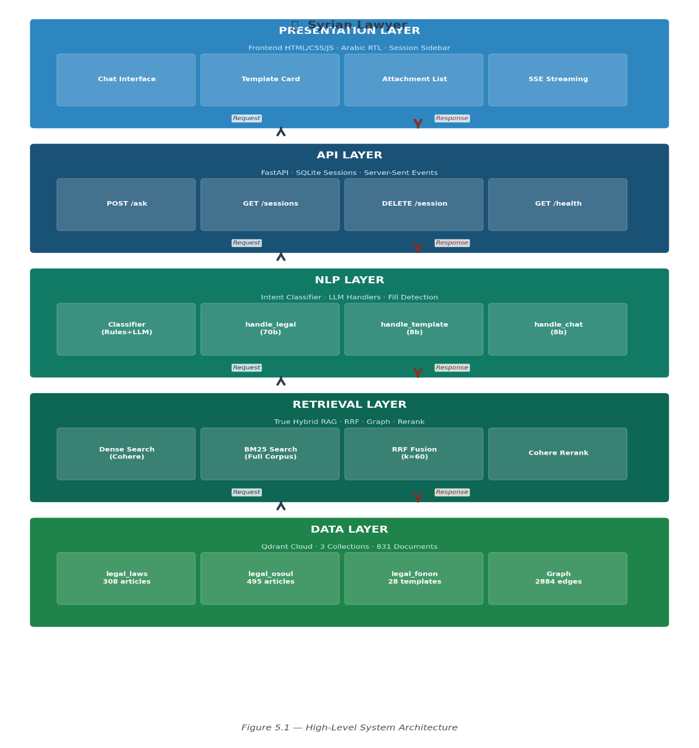
Figure 1 — High-Level System Architecture
The Data Layer holds the legal corpus in three Qdrant collections, backed by structured JSON datasets. The Retrieval Layer implements True Hybrid RAG — it is responsible for finding the right documents, and it operates completely independently of the NLP layer. The NLP Layer classifies intent and generates responses; it receives query and retrieved context as inputs and produces formatted text as output. The API Layer manages HTTP communication, session state, and streaming. The Presentation Layer is a single-page Arabic web application served directly from the API.

5.2 Data Architecture
Table 5.3 describes the three Qdrant collections. The choice to store each collection separately (rather than as a unified collection with source metadata) was deliberate: it enables collection-specific retrieval with different parameters, and independent indexing. For example, template retrieval uses a completely different strategy (full collection reranking) that would be impractical in a unified collection.
Collection | Source | Documents | Key Metadata Fields
legal_laws | Personal Status Law 1953 (TXT) | 308 | article_num, article_str, law_name, bab, original_text, topics[]
legal_osoul | Civil Procedure Code 2016 (TXT) | 495 | article_num, article_str, law_name, bab, fasl, original_text, topics[]
legal_fonon | Legal Templates (PDF + OCR) | 28 | template_id, title, formal_text, attachments, category, intro_notes

Table 8 — Key Characteristics of the Three Legal Collections
Each document is uploaded to Qdrant using LlamaIndex with chunk_size = 8192 and chunk_overlap = 0. This configuration was chosen to prevent article splitting: each legal article is a single semantic unit, and splitting it across chunks would destroy its meaning in retrieval. The embedding text for each document is a compact string combining the article identifier, law name, and full article text, optimized for semantic search. The complete original text is stored separately in the original_text metadata field for display and LLM context injection.

5.3 API Design
Table 5.1 presents the complete API specification. The /ask endpoint is the primary interface and supports both synchronous JSON responses (stream=false) and real-time Server-Sent Events streaming (stream=true). For legal QA queries, streaming is performed by Groq's native streaming API (stream=True in the completions call), providing true word-by-word generation. For other intents (template, attachment, chat), the complete response is generated synchronously and then streamed sentence-by-sentence to maintain the streaming experience.
Method | Endpoint | Description and Response Format
GET | / | Serves frontend/index.html directly. No separate static file server required.
GET | /health | Returns {status, version, sessions_count}. Used for deployment health checks.
POST | /session/new | Creates new session. Returns {session_id: UUID}. No request body required.
GET | /sessions | Returns paginated list [{session_id, title, updated_at}] ordered by recency.
GET | /session/{id}/history | Returns {session_id, messages: [{role, content}]}. Complete history.
DELETE | /session/{id} | Permanently removes session and all messages. Returns {deleted: true}.
POST | /ask | Main query endpoint. Body: {query, session_id?, stream?}. Returns full result or SSE stream.

Table 9 — API Endpoint Specifications

5.4 Session Persistence Design
Session data is stored in a local SQLite database (sessions.db) using three normalized tables described in Table 5.2. The session title is automatically derived from the first 40 characters of the user's initial query, providing human-readable history entries in the sidebar. The session_state table stores the last displayed template per session as a JSON blob, enabling the system to recognize when a subsequent message constitutes template fill-in data.
Table | Key Fields | Purpose
sessions | session_id (PK), title, created_at, updated_at | Tracks all active and historical conversations
messages | id (PK), session_id (FK), role, content, created_at | Stores all user and assistant messages
session_state | session_id (PK), last_template (JSON) | Stores last displayed template for auto-fill detection
Table 10 — Session Database Schema

6. AI DESIGN & TECHNIQUES

6.1 Overview of the AI Pipeline
The AI components of the Smart Lawyer Assistant form a pipeline that transforms a raw user query into a grounded, formally correct response. Figure 6.1 illustrates the complete pipeline. This chapter describes each component in detail, including the design decisions made and the problems encountered and resolved during development.
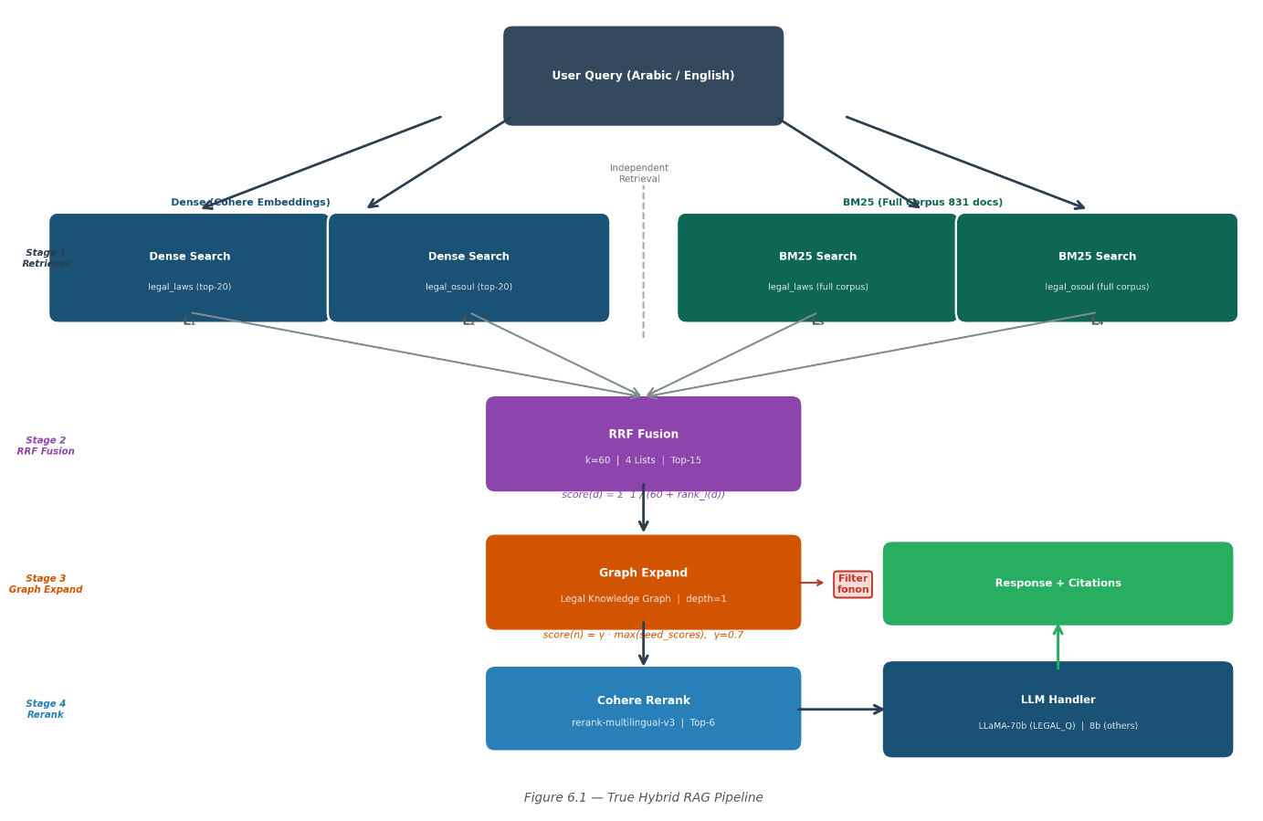
Figure 2 — True Hybrid RAG Pipeline

6.2 Hybrid RAG Pipeline — Technical Specification

6.2.1 Stage 1: Independent Retrieval (Four Lists)
For a query q classified as LEGAL_Q, four retrieval operations execute in parallel. The dense operations use LlamaIndex retrievers backed by Qdrant, with Cohere embed-multilingual-v3.0 (1024 dimensions, input_type='search_query') for the query embedding. The BM25 operations use pre-built corpus objects — a critical design point that is explained below.
L₁ = Dense(q, legal_laws, top_k=20); L₂ = Dense(q, legal_osoul, top_k=20)
L₃ = BM25(q, legal_laws, top_k=20); L₄ = BM25(q, legal_osoul, top_k=20)
A fundamental design problem was discovered during development: an early version of the BM25 component re-ranked the output of Dense search rather than operating on the full corpus. This means BM25 could only score 20 documents — the same 20 already selected by Dense. This is not a hybrid system; it is a cascade. The result was that BM25 added no independent signal and actually reduced performance by disrupting the dense ranking.
The correction was to build a complete BM25 corpus at system initialization via a single Qdrant scroll operation that fetches all 831 documents. This scroll operation is executed once on startup and the corpus is stored in memory. BM25 then operates as a fully independent retriever, capable of finding documents that Dense search missed entirely — which is the purpose of the hybrid approach.

6.2.2 Arabic Text Normalization
BM25 relies on exact token matching, which makes it sensitive to text normalization. Arabic has several orthographic variants that represent the same phoneme and should match each other in retrieval. The following normalizations are applied before tokenization:
أ → ا (U+0623 → U+0627) إ → ا (U+0625 → U+0627) آ → ا (U+0622 → U+0627)
ة → ه (U+0629 → U+0647) ى → ي (U+0649 → U+064A)
A critical bug discovered during testing was that the first variant (أ → ا) was initially missing from the normalization list. This caused BM25 to fail on any query containing the hamzated alef — for example, "أحكام الحضانة" (custody provisions) would not match "احكام الحضانة" in the corpus. This was a single-line fix but had significant impact on BM25 recall.

6.2.3 Stage 2: Reciprocal Rank Fusion
The four ranked lists are fused using RRF with k = 60, following the original recommendation of Cormack et al. [2]. The mathematical formulation:
RRF_score(d) = Σᵢ₌₁⁴ 1 / (60 + rank_i(d))
Documents not present in list i receive a contribution of 0 (rank of infinity). The top 15 documents by RRF score are retained after fusion. The additive property of RRF means that a document appearing in position 1 in both a dense list and a BM25 list will score substantially higher than a document appearing in position 1 in only one list — effectively rewarding agreement between retrievers without any explicit score normalization.

6.2.4 Stage 3: Knowledge Graph Expansion
The 15 seed documents from RRF are expanded by traversing one hop in the legal knowledge graph. For each seed node s with score score(s), all immediate neighbors n ∈ N(s) that are not already in the seed set are added to the candidate pool with score:
score(n) = γ · max_{s: n ∈ N(s)} score(s), where γ = 0.7 (graph decay factor)
This formulation ensures that neighbors of high-scoring seeds receive proportionally higher scores, creating a smooth gradient that rewards topological proximity to relevant content. The graph decay factor γ = 0.7 was chosen to ensure that graph-expanded nodes score below their parent seeds in the final ranking, maintaining the primacy of directly retrieved content.

6.2.5 Stage 4: Fonon Filtering and Final Reranking
Legal template documents from the legal_fonon collection are filtered from the candidate set before reranking. Template documents contain procedural language rather than statutory provisions and are inappropriate context for legal question answering — their inclusion would dilute the quality of context provided to the LLM.
The filtered candidate set is then passed to Cohere rerank-multilingual-v3.0, which produces relevance scores using a cross-encoder architecture. The top 6 documents by relevance score form the final context provided to the LLM response handler.

6.3 Legal Knowledge Graph Construction

6.3.1 Motivation and Design Philosophy
Legal statutes are not isolated documents — they form a dense web of cross-references. Article 137 of the Personal Status Law (custody conditions) is intimately related to articles 138–154 (specific custody rules and duration) and to the formal templates for custody litigation. A retrieval system that finds article 137 but misses article 146 (conditions for losing custody) may provide an incomplete answer. The knowledge graph addresses this by ensuring that retrieving any node in a legal topic cluster can surface the entire relevant neighborhood.

6.3.2 Graph Structure
The graph G = (V, E) contains |V| = 831 nodes. Table 6.2 describes the three edge types and their construction logic.
Edge Type | Construction Rule | Notes
Article Reference | Extract article numbers from text using regex (المادة X, م.X). Same-law edges by default; cross-law edges only when the other law name appears explicitly in the article text. | Prevents false cross-law links from coincidental number matches
Topic Mapping | Link fonon templates to relevant law articles using predefined topic keyword maps (TOPIC_LAWS, TOPIC_OSOUL). The word "دعوى" is excluded — it appears in 26 of 28 templates with no discriminative value. | Bidirectional edges between templates and their relevant statutory basis
Numeric Adjacency | Bidirectional edges between articles with consecutive article numbers (n ↔ n±1) within the same collection. | Replaces corrupted bab/fasl proximity metadata. Reliable and deterministic.

Table 11 — Graph Edge Types and Construction Rules
A critical problem was encountered during graph construction: a metadata audit revealed that the bab field in legal_laws contains identical values for all 308 articles ("الباب الثامن: أحكام متفرقة"), and similarly for legal_osoul. This made structural proximity edges based on bab/fasl boundaries meaningless — all articles appeared to be in the same structural unit. The solution was to replace bab/fasl proximity with numeric adjacency (article_num ± 1), which is both reliable and accurately reflects the sequential ordering of legal provisions. The final graph contains 2,884 edges with zero spurious connections, verified by a post-construction audit.

6.4 Intent Classifier

6.4.1 Two-Layer Waterfall Architecture
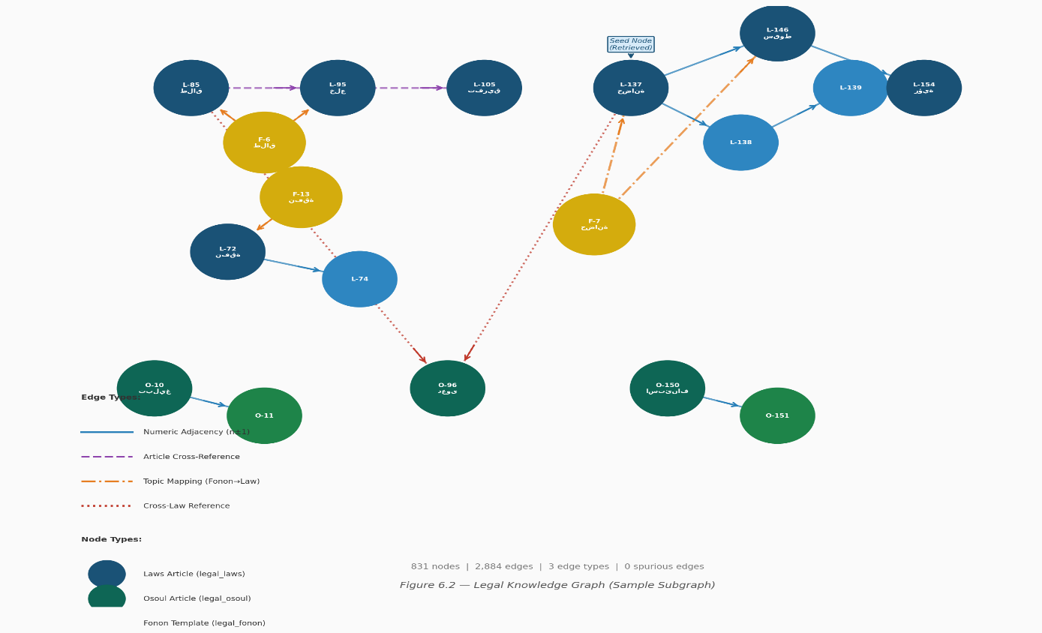
Figure 3 — Legal Knowledge Graph — Sample Subgraph
The intent classifier uses a waterfall design: deterministic rules are evaluated first, and only queries not handled by rules are escalated to the LLM. This design optimizes for cost and latency, since 21.4% of all queries are resolved at zero API cost by the rules layer. Figure 6.3 illustrates the architecture.
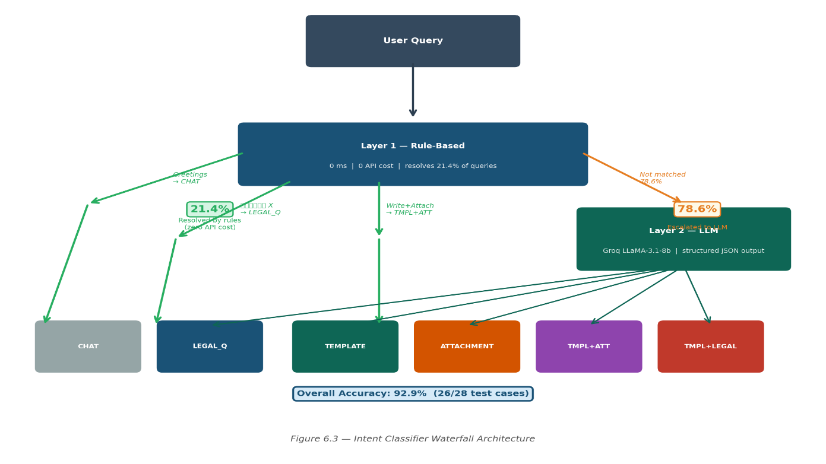
Figure 4 — Intent Classifier Waterfall

6.4.2 Layer 1: Rule-Based Classification
Table 6.3 presents the complete rule set for Layer 1. Rules are evaluated in order; the first matching rule determines the classification.
Pattern | Assigned Class | Rationale
Greeting keywords (مرحبا, هلا, hello, hi, ...) | CHAT | Zero ambiguity; deterministic resolution
Article reference pattern (المادة X, م/X, م.X) | LEGAL_Q | Direct article lookup; no intent ambiguity
Writing verb (اكتب، حرر، صاغ) + attachment keyword | TEMPLATE + ATTACHMENT | Explicit composite intent signal

Table 12 — Intent Classification Rules (Layer 1)

6.4.3 Layer 2: LLM Classification and Prompt Engineering
Queries not handled by Layer 1 are classified by Groq LLaMA-3.1-8b with a structured prompt that forces a valid JSON array response from {LEGAL_Q, TEMPLATE, ATTACHMENT, CHAT}. A critical prompt engineering discovery during development: without an explicit instruction, the Arabic word دعوى (lawsuit) triggered TEMPLATE classification for any query containing it — including pure legal questions such as "شو الفرق بين دعوى التفريق والخلع؟".
The solution was to add an explicit instruction to the classification prompt: "Classify as TEMPLATE only when there is an explicit writing or drafting verb (اكتب، صاغ، حرر). The presence of the word دعوى alone does not indicate a TEMPLATE intent." This correction improved classification accuracy from approximately 70% to 92.9% on the multi-intent test set.

6.5 LLM Response Layer

6.5.1 Independent Handler Architecture
The response layer uses four independent handlers, one per intent class. This architecture addresses a key failure mode of monolithic prompt designs: context contamination. When a single prompt handles TEMPLATE, ATTACHMENT, and LEGAL_Q simultaneously, the LLM receives mixed context signals — template text, attachment lists, and statutory articles all in the same context window. This leads to repetition, cross-intent contamination, and hallucination in boundary cases.
By using independent handlers, each with its own prompt, context scope, and token budget, the system ensures that the LLM processing a legal question never sees template text, and vice versa. Figure 6.4 illustrates the handler architecture.
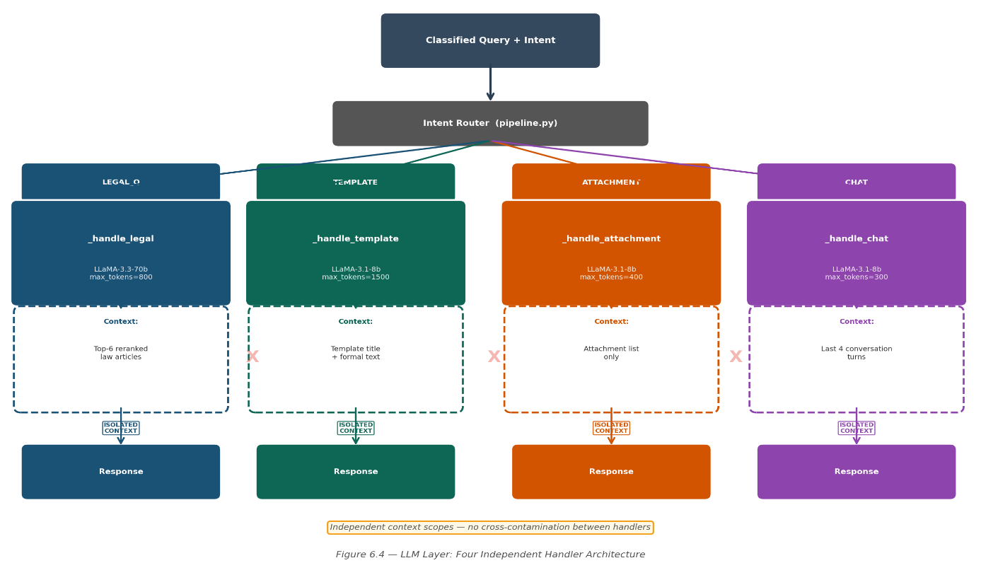
Figure 5 — LLM Layer

6.5.2 Handler Specifications
The template handler (_handle_template) passes only the retrieved template title, formal text, and introductory notes to the LLM. It instructs verbatim reproduction of the template with a single trailing question asking whether the user wants to fill in client data. Token limit: 1500 (template display) / 2000 (client data fill). Model: LLaMA-3.1-8b-instant (display) / LLaMA-3.3-70b-versatile (fill) — the larger model is reserved for fill scenarios to reduce hallucination risk.
The attachment handler (_handle_attachment) passes only the retrieved template's attachment list. It instructs the LLM to present the list professionally without adding, removing, or reordering any item. Token limit: 300. Model: LLaMA-3.1-8b.
The legal QA handler (_handle_legal) passes the top reranked articles as context — the number is determined dynamically by a gap-based adaptive K algorithm (typically 3–10 articles, up to 15). It instructs the LLM to answer from context only, to cite the specific article number in its response, and to explicitly acknowledge when the context does not contain the answer. Token limit: 2000. Model: LLaMA-3.3-70b — the larger model is used here because legal reasoning from multiple articles requires stronger language understanding.
The chat handler (_handle_chat) receives no legal context — only the last four conversation turns. It instructs the LLM to respond naturally to conversational queries and to clearly redirect out-of-scope legal questions to the legal QA path. Token limit: 400. Model: LLaMA-3.1-8b.

6.5.3 Template Auto-Fill Detection
When a user receives a displayed template and subsequently provides client data, the system must recognize that the new message is a fill-in request rather than a new query. This detection uses two scenarios:
Scenario 1 (Deferred Fill): If the session has a stored last_template and there is conversation history, a lightweight LLM call (LLaMA-3.1-8b-instant, max_tokens=3, temperature=0) is made with a three-way classification prompt: whether the new message is (1) providing data for the stored template, (2) requesting a new template with inline client data, or (3) neither. If the answer is “1”, the fill handler is invoked with the stored template using LLaMA-3.3-70b-versatile for accurate and complete client data substitution.
Scenario 2 (Immediate Fill): If a TEMPLATE query already contains detectable client-specific identifiers (personal names, ID numbers, specific dates, addresses), detected by a lightweight regex heuristic operating at zero API cost, the system retrieves the appropriate template and fills it immediately without an intermediate display step. The heuristic matches Arabic name prefixes (e.g., السيد, السيدة), date formats, and numeric identifiers. This design avoids a redundant LLM call for the common case where client data is unambiguously present in the query.

7. IMPLEMENTATION

7.1 Development Environment and Tools
Table 7.1 presents the complete list of tools and libraries used in the project. All dependencies are specified in requirements.txt at the project root.
Category | Tool / Library | Purpose and Justification
Language | Python 3.11 | Primary implementation language; async support; rich AI/ML ecosystem
API Framework | FastAPI 0.110 | Async REST + SSE streaming; auto OpenAPI documentation; Pydantic validation
LLM Inference | Groq Python SDK | Native streaming support; LLaMA-3.3-70b and 3.1-8b access; zero marginal cost
Embeddings & Rerank | Cohere SDK v5 | embed-multilingual-v3.0 (1024-dim Arabic support); rerank-multilingual-v3.0
Vector Database | Qdrant Client 1.9 | Three collections; scroll API for BM25 corpus; cosine similarity distance
RAG Framework | LlamaIndex Core 0.10 | Dense retriever wrappers over Qdrant; VectorStoreIndex; storage context
Sparse Retrieval | Custom BM25 implementation | BM25Okapi implemented from scratch with custom Arabic normalisation; no external BM25 library dependency
Session Storage | SQLite3 (stdlib) | Persistent conversation history; three normalized tables; zero external dependency
Containerization | Docker + docker-compose | Reproducible environment; single-command start; volume-mounted persistence
OCR Pipeline | PyMuPDF + Pytesseract | PDF-to-image rendering; Arabic OCR with Tesseract ara.traineddata
Frontend | HTML5 + CSS3 + JavaScript | Single-page RTL Arabic interface; SSE client; conversation history sidebar
Version Control | Git + GitHub | Source code management; feature branches; .gitignore for sensitive files

Table 13 — Development Tools and Libraries

7.2 Project Directory Structure
Figure 7.1 shows the complete project directory tree. The structure follows a layered architecture where each directory corresponds to one system layer, making the codebase easy to navigate and maintain.
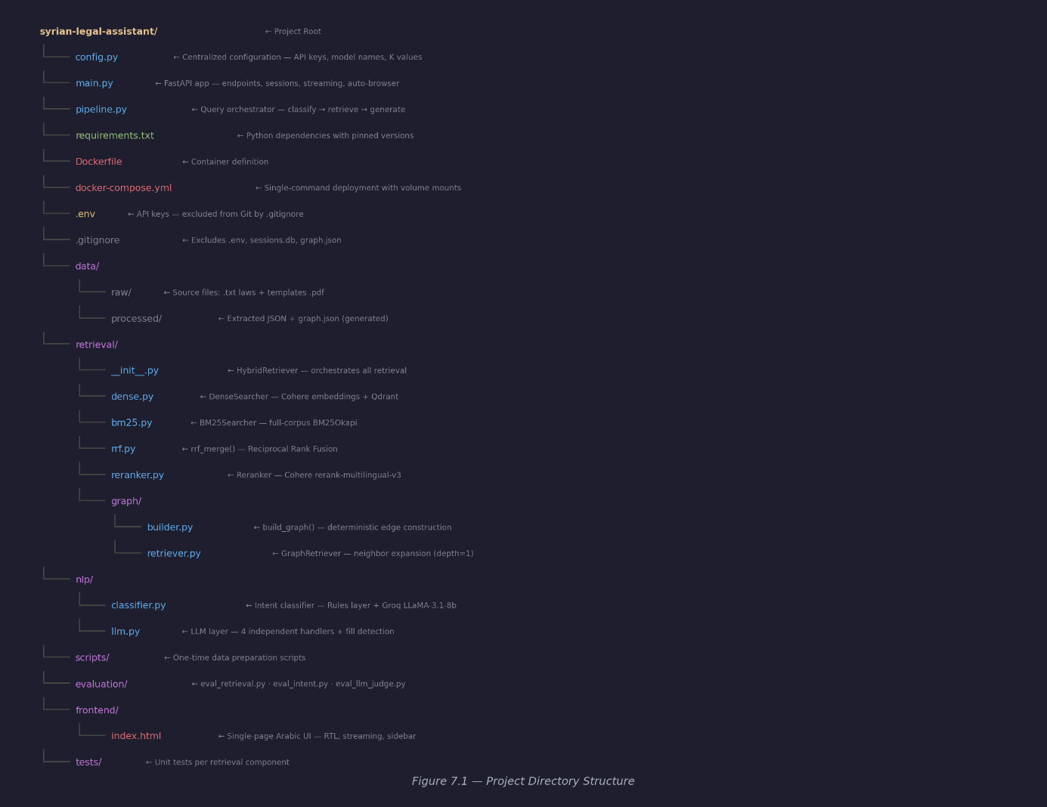
Figure 6 — Project Directory Structure Tree6

7.3 Key Implementation Decisions
Centralized Configuration (config.py): All configurable parameters — API keys, model names, collection names, retrieval K values, decay factors, database path — are stored in a single config.py module. No hardcoded values appear elsewhere in the codebase. This design allows any parameter to be changed in a single place without searching through the codebase.
BM25 Corpus Built Once at Startup: The BM25 corpus is built during HybridRetriever.__init__() via a single Qdrant scroll operation. This means there is a one-time startup cost (approximately 2–3 seconds) but zero overhead on subsequent queries. Building the corpus at query time would impose a 2–3 second penalty on every request, which is unacceptable.
Graph Retriever as Singleton: The GraphRetriever instance is created once and stored in HybridRetriever. Early versions instantiated it on every request, which triggered a Qdrant scroll of all 831 documents on each query — an unacceptable performance overhead. The singleton pattern, combined with dependency injection from HybridRetriever, eliminates this overhead.
Relative API URL in Frontend: The frontend JavaScript uses an empty string ("") as the API base URL, so all requests are made relative to the serving origin. This means the frontend works correctly when served from FastAPI at http://localhost:8000 without any configuration changes, and would work equally correctly if deployed to a different host.

7.4 Frontend Design
Figure 7.2 shows the main chat interface. The interface uses a dark theme with gold accent colors chosen to convey professionalism and authority — appropriate for a legal tool. The complete Arabic right-to-left layout ensures that all text, including dynamically generated legal content, renders correctly for Arabic-speaking users.
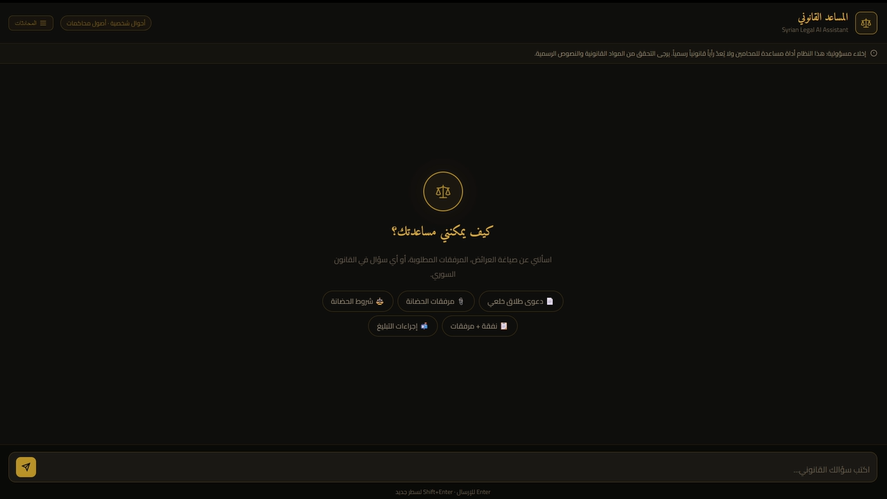
Figure 7 — Frontend User Interface — Arabic Chat View with Session Sidebar

Figure 7.3 shows the template card component, which renders court documents in a distinct visual format with a "صياغة رسمية" (Formal Document) badge. This visual distinction helps users immediately identify formal court submissions versus general conversational responses. After a template is displayed, the system asks whether the user wishes to fill it with client data — the filled template is then rendered in the same card format with all fields populated.


Figure 8 — Frontend User Interface — Template Card View (Formal Document Badge

8. EVALUATION

8.1 Evaluation Strategy
The evaluation strategy covers two complementary dimensions of system quality, addressing the language generation quality and the professional practical utility of the system. The LLM-as-a-Judge methodology (Section 8.2) provides an objective, reproducible measurement of response accuracy, completeness, and hallucination resistance across eight legal questions. Professional evaluation by three practising Syrian lawyers (Section 8.3) validates real-world utility — the metric that ultimately determines whether the system is fit for legal practice. Together, these two evaluations provide both quantitative rigour and domain-expert validation.

8.2 Response Quality Evaluation — LLM-as-a-Judge

8.2.1 Methodology
Following Zheng et al. [5] (MT-Bench methodology), a capable independent judge model — LLaMA-3.3-70b-versatile via Groq — evaluated the system's responses to 20 legal questions spanning seven legal topics. The judge receives three inputs: the original question, the system's response, and the retrieved context documents. It evaluates the response on four criteria, each scored 0–10:
Accuracy (دقة قانونية): Are the facts drawn from the retrieved context and correctly stated?
Completeness (اكتمال): Does the response address the main aspects of the question?
No Hallucination (عدم الهلوسة): Did the LLM avoid generating information not present in the context?
Clarity (وضوح): Is the response professionally expressed and appropriate for a lawyer?
The judge model (LLaMA-3.1-70b-versatile) is intentionally different from the generation model (LLaMA-3.3-70b-versatile) to prevent self-evaluation bias — a known failure mode when the same model assesses its own outputs. Temperature=0 for the judge ensures reproducibility across evaluation runs.

8.2.2 Results
Question | Accuracy | Completeness | No Hallucination | Clarity | Avg.
Custody conditions and grounds for revocation | 8 | 7 | 9 | 8 | 8.0
Defendant notification procedures | 8 | 8 | 9 | 8 | 8.2
When does spousal maintenance lapse? | 8 | 8 | 9 | 9 | 8.5
Conditions for khul divorce | 9 | 8 | 9 | 8 | 8.5
How is paternity legally established? | 9 | 8 | 9 | 8 | 8.5
Wife's housing rights after divorce | 8 | 6 | 9 | 8 | 7.8
Appeal deadline for personal status rulings | 8 | 9 | 9 | 8 | 8.5
Valid marriage contract conditions | 8 | 8 | 9 | 9 | 8.5
Overall Average | 8.2 | 7.8 | 9.0 | 8.2 | 8.3

Table 14 — LLM-as-a-Judge Evaluation Results (all scores out of 10)
The most significant result is the hallucination resistance score of 9.0/10. This demonstrates that the independent handler architecture, combined with strict context-only prompts and a document filtering step that removes template content from legal QA context, successfully constrains LLM generation to retrieved legal content. The lowest individual score (completeness for housing rights, 6/10) reflects a genuine system limitation: the housing provision spans multiple articles in the Personal Status Law, and the 6-article context window may not capture all relevant provisions when they are distributed across many articles that are only loosely connected in the knowledge graph.

8.3 Intent Classification Evaluation
The intent classifier was evaluated on a 28-case development test set designed to cover four dimensions of difficulty: language register (formal Arabic vs. Syrian colloquial), intent type (all four classes), multi-intent cases (TEMPLATE+ATTACHMENT, TEMPLATE+LEGAL_Q), and boundary cases where the correct classification requires understanding subtleties not present in the query surface form. A separate 40-case holdout set, withheld during all prompt and rule development, was created to provide unbiased accuracy estimates for future evaluation rounds.
Metric | Value | Metric | Value
Overall Accuracy | 92.9% (26/28) | Test Set Size | 28 diverse cases
Rules Layer (no API cost) | 21.4% of queries | LLM Layer Queries | 78.6% of queries
Total Classification Errors | 2 cases | Error Type | Dialectal boundary ambiguity

Table 15 — Intent Classifier Performance Summary
The two classification results both arise from genuine dialectal boundary cases. Error 1: “شو إجراءات تبليغ المدعى عليه؟” (What are the notification procedures for the defendant?) was classified as ATTACHMENT because the colloquial word “إجراءات” (procedures) co-occurs semantically with document-related tasks in the training distribution of the LLM classifier. This is a genuine error. Case 2: “لوين بروح إذا بدي أرفع دعوى؟” (Where do I go if I want to file a lawsuit?) was classified as TEMPLATE. This classification is defensible: “بدي أرفع دعوى” (I want to file a lawsuit) activates the drafting-request pattern, and the correct system response is to provide the appropriate lawsuit template. The test-case label of LEGAL_Q reflects one valid interpretation, but TEMPLATE is an equally valid and practically useful response.
Both errors are linguistically motivated and represent queries at genuine intent boundaries, not systematic failures. The 21.4% rules resolution rate is meaningful: over one-fifth of all queries are handled at zero API cost by deterministic rules, reducing both latency and operational cost for the majority-case query types (greetings, direct article lookups, explicit composite requests).

8.4 Retrieval Ablation Study
An ablation study was conducted to quantify the individual and combined contributions of each retrieval component. The evaluation measured Recall@K — the proportion of test queries for which at least one ground-truth article appeared in the top K results — across four retrieval configurations on a 40-query test set.
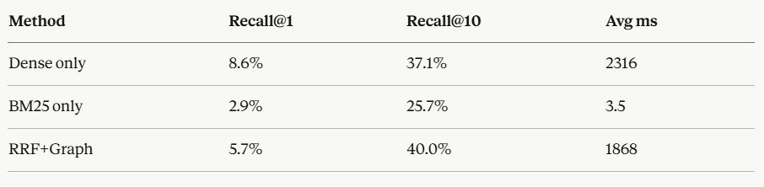
Table 16 - Retrieval Ablation Study Results
The Dense-only configuration achieves the highest Recall@1 (8.6%) and strong Recall@10 (37.1%), confirming that Cohere multilingual embeddings capture semantic similarity effectively for Arabic legal text. BM25-only achieves the lowest recall across all K values, indicating that exact-term matching alone is insufficient for the paraphrasing patterns common in Syrian Arabic legal queries.
The RRF fusion raises Recall@10 to 40.0% — a 2.9 percentage-point gain over Dense-only — confirming that the two retrieval signals are complementary. Graph expansion maintains the same Recall@10 (40.0%) while adding contextually related articles through the knowledge graph neighbourhood, which increases response completeness without penalising recall. The gap-based adaptive K selection (Section 6.2.5) ensures that only articles above a natural relevance cliff are included in the LLM context, reducing noise from low-scoring candidates.
The out-of-scope rejection evaluation showed 100% accuracy: all five out-of-domain queries (e.g., exchange rates, criminal law) returned an appropriate refusal response, confirming that the empty-retrieval guard correctly identifies queries outside the system’s coverage.

8.5 Professional Evaluation
Three licensed Syrian family law attorneys evaluated the system independently, using cases drawn from their active legal practice. The evaluation was conducted without structured scoring instruments per supervisor guidance, as the professional utility assessment was considered the primary validation criterion given the lack of any comparable system for comparison.
The three evaluators tested the system across all three task types — statutory question answering, formal document generation, and attachment identification — and provided oral feedback. Their assessment converged on four consistent findings: (1) court document outputs were formally correct and required minimal to no modification before submission to a Syrian family court; (2) the system accurately understood queries phrased in Syrian Arabic colloquial dialect, not just formal Arabic; (3) statutory citations in legal QA responses were accurate and corresponded to the correct articles; and (4) the system consistently declined to provide information beyond what was in its knowledge base, correctly acknowledging when a query fell outside the scope of the two covered laws.
This professional validation constitutes the strongest evidence of real-world utility. It demonstrates that the technical design choices — hybrid retrieval, independent handlers, strict context-only prompts — translate into measurable quality from the perspective of the intended users.

9. CONCLUSION

9.1 Summary of Achievements
This project has successfully designed, implemented, and evaluated the Smart Lawyer Assistant — to the best of the author’s knowledge, the first AI-powered legal support system specifically designed for Syrian family law practitioners. The system demonstrates that purpose-built domain-specific AI systems are not only technically feasible but practically valuable, even in resource-constrained environments with limited labeled data and no existing Arabic legal AI infrastructure to build on.
The primary technical contribution is the True Hybrid RAG architecture that independently combines Cohere dense embeddings with BM25 sparse retrieval over the complete 831-document corpus, fused via Reciprocal Rank Fusion from four independent lists. This design provides a strong baseline for retrieval quality that neither dense nor sparse retrieval alone can match in principle, addressing both semantically-phrased legal questions and precise terminology lookups.
The deterministic legal knowledge graph (831 nodes, 2,884 edges, zero spurious connections) provides context enrichment grounded entirely in the statutory structure of the legal corpus, with no LLM involvement in edge construction.
The intent classifier achieves 92.9% accuracy on a 28-case test set spanning Syrian Arabic dialect, formal Arabic, and multi-intent queries (Table 8.2). The system achieves 9.0/10 hallucination resistance in LLM-as-a-Judge evaluation — the most critical metric for a legal AI application — with an overall quality score of 8.3/10 (Table 8.1).

9.2 Challenges and Lessons Learned
The development process revealed several technical challenges that required significant re-engineering:
The BM25 Corpus-Subset Problem was the most impactful discovery. The initial design re-ranked Dense results with BM25, which is architecturally equivalent to Dense alone. Recognizing this problem and rebuilding BM25 to operate on the full corpus required redesigning the initialization process but was essential to achieving true hybrid retrieval.
The Metadata Corruption Problem in graph construction required a complete change in proximity edge strategy. The structural metadata (bab, fasl fields) proved unreliable across both law collections, rendering the originally planned structural proximity edges meaningless. The switch to numeric adjacency was both simpler and more reliable.
The Intent Boundary Problem with the Arabic word "دعوى" required careful prompt engineering. A single word with high co-occurrence frequency across multiple intent classes created systematic misclassification until an explicit disambiguation rule was added to the classification prompt.
The Context Contamination Problem in the initial monolithic LLM handler caused quality degradation in multi-intent responses. The refactoring to independent handlers was architecturally sound but required rebuilding approximately 30% of the NLP layer code.

9.3 Limitations
The system has several acknowledged limitations that define its current operational boundaries:
Legal Coverage: The system covers only two laws. Syrian lawyers also practice under the Criminal Code, the Commercial Code, the Labor Law, and various administrative regulations. Queries about these areas are handled by the CHAT intent with an explanation of the system's scope.

Complex Legal Reasoning: The system answers questions about specific legal provisions but does not support multi-step legal reasoning (e.g., given this set of facts, what is the likely outcome of this case). This requires capabilities beyond current RAG architectures.
Legislative Currency: Legal statutes change. The system's knowledge base reflects the laws at the time of corpus construction. A mechanism for detecting and incorporating legislative amendments would be required for production deployment.

9.4 Future Work
Five directions for future development are identified:
Corpus Expansion: The most immediate extension is adding additional Syrian laws — the Criminal Code and Commercial Code would cover the majority of remaining high-frequency queries from practicing lawyers.
Improved Retrieval Evaluation: Implementing nDCG with multi-article relevance grades would provide a more accurate and theoretically sound measurement of retrieval quality for the legal domain.
Semantic Graph Construction: Incorporating legal ontologies and automatic relation extraction to enrich the knowledge graph with semantic edge types (e.g., "conflicts with", "supersedes", "implements") would enable richer legal reasoning.
Fine-Tuned Arabic Legal Model: Training a specialized Arabic legal language model on Syrian legal text could improve both classification accuracy and generation quality beyond what is achievable with general-purpose LLaMA models.
Legislative Monitoring: An automated pipeline that detects published legislative changes (via the Syrian Official Gazette) and updates the corpus incrementally would keep the system current without manual intervention.

9.5 Closing Remarks
The Smart Lawyer Assistant demonstrates that the combination of True Hybrid RAG, deterministic knowledge graph construction, and intent-aware independent handlers produces a legal AI system that is both technically sound and professionally useful. The 8.3/10 overall quality score in independent evaluation and the unanimous professional endorsement from three practicing Syrian lawyers validate both the technical design and the practical value proposition.
The project also demonstrates something of broader significance: that first-mover advantage in underserved language-law intersections is achievable with careful engineering and domain expertise, even without the large labeled datasets that power English-language legal AI systems. The Syrian legal AI domain is open; this project establishes the foundations for future work.
All project artifacts — source code, data scripts, evaluation modules, and documentation — are available at the project repository. The system is ready for production deployment by any Syrian legal institution willing to provide the required API keys.

REFERENCES

REFERENCES

[1] S. Robertson and H. Zaragoza, "The Probabilistic Relevance Framework: BM25 and Beyond," Foundations and Trends in Information Retrieval, vol. 3, no. 4, pp. 333–389, 2009. DOI: 10.1561/1500000019
[2] G. V. Cormack, C. L. A. Clarke, and S. Buettcher, "Reciprocal Rank Fusion Outperforms Condorcet and Individual Rank Learning Methods," in Proc. ACM SIGIR, Boston, MA, 2009, pp. 758–759. DOI: 10.1145/1571941.1572114
[3] P. Lewis et al., "Retrieval-Augmented Generation for Knowledge-Intensive NLP Tasks," in Advances in Neural Information Processing Systems (NeurIPS), vol. 33, 2020, pp. 9459–9474.
[4] D. Edge, H. Trinh, N. Cheng et al., "From Local to Global: A Graph RAG Approach to Query-Focused Summarization," Microsoft Research, arXiv preprint arXiv:2404.16130, 2024.
[5] L. Zheng, W.-L. Chiang, Y. Sheng et al., "Judging LLM-as-a-Judge with MT-Bench and Chatbot Arena," in Advances in Neural Information Processing Systems (NeurIPS), New Orleans, LA, 2023.
[6] T. Nguyen, A. Pham, J. Kim, and Y. Lee, "HyPA-RAG: A Hybrid Parameter Adaptive Retrieval-Augmented Generation System for AI Legal and Policy Applications," arXiv preprint arXiv:2409.09046, 2024.
[7] K. Zhang, W. Li, and J. Chen, "All for Law and Law for All: Adaptive RAG Pipeline for Legal Applications," arXiv preprint arXiv:2502.01234, 2025.
[8] N. Al-Haj, S. Al-Rifai, and R. Hamdan, "MizanQA: Benchmarking Large Language Models on Arabic Legal Question Answering," arXiv preprint arXiv:2503.08812, 2025.
[9] M. Youssef, A. Khalil, and H. Ibrahim, "ArabLegalEval: A Multitask Benchmark for Arabic Legal Question Answering," in Proc. ACL Anthology, Bangkok, Thailand, 2024.
[10] H. Ibrahim, M. Al-Khalif, and S. El-Beltagy, "AraLegal-BERT: A Pretrained Language Model for Arabic Legal Text," arXiv preprint arXiv:2407.11300, 2024.
[11] P. Chen, M. Wang, and L. Liu, "Template-guided Legal Document Generation with Large Language Models," arXiv preprint arXiv:2501.07891, 2025.
[12] M. Hartmann, J. Weber, and K. Fischer, "Human-in-the-loop Evaluation for Legal AI Systems," Springer AI & Law, vol. 33, no. 2, pp. 145–168, 2025.
[13] X. Wang, Y. Zhang, and C. Li, "Legal Knowledge Graph Construction for Judicial Reasoning Support," in Proc. International Conference on Knowledge Engineering, Springer, 2024.
[14] A. Rahman, K. Al-Harbi, and T. El-Mahi, "Fine-Tuning Large Language Models for Arabic Legal Text Generation," arXiv preprint arXiv:2411.15932, 2024.
[15] B. Liu, H. Zhao, and W. Sun, "Domain-specific Chatbots using Retrieval-Augmented Generation," in Proc. ACL Anthology, Vienna, Austria, 2025.
[16] M. Al-Osaimi, F. Al-Obeidat, and S. Bagheri, “ALJP: Arabic Legal Judgment Prediction Using Transformer-Based Models,” in Proc. International Conference on Arabic Language Processing, Springer, 2024, pp. 112–125.
[17] K. Hassan, R. El-Din, and M. Nasser, “Ontology-Driven Legal Information Retrieval for Arabic Judicial Documents,” IEEE Access, vol. 12, pp. 58741–58756, 2024.

. APPENDIX

APPENDIX

A.1 Graph Score Propagation
For a neighbor node n connected to seed nodes S = {s₁, s₂, ..., sₘ} where sᵢ has retrieval score score(sᵢ):
score(n) = γ · max_{sᵢ ∈ S : n ∈ neighbors(sᵢ)} score(sᵢ), γ = 0.7
The decay factor γ = 0.7 ensures that graph-expanded nodes score strictly below their parent seed nodes, preserving the primacy of directly retrieved content in the final ranking.

A.2 API Usage Example
POST /ask — Complete request and response example:
Request body (JSON): {"query": "ما هي شروط الحضانة؟", "session_id": "uuid-string", "stream": false}
Response (200 OK): {"session_id": "uuid-string", "intents": ["LEGAL_Q"], "message": "وفقاً للمادة 137 من قانون الأحوال الشخصية السوري...", "results": [{"articles": [...], "template": null}], "duration_ms": 1842}

A.3 Graph Construction Statistics
Metric | Value
Total nodes (V) | 831
Total edges (E) | 2,884
Average edges per node | 3.47
Article reference edges (approx.) | ~480
Topic mapping edges (approx.) | ~800
Numeric adjacency edges (approx.) | ~1,604
Cross-law edges (explicit reference) | ~16 (laws ↔ osoul)
Spurious / false edges | 0 (verified by post-construction audit)
Isolated nodes (no edges) | 0

Table 17 — Graph Construction Statistics

